CREATING A WEBSITE ON

LINUX (CENTOS Stream 9)

A STEP-BY-STEP GUIDE

PRESENTER : KHASAB ARSHAD BASHA

TRAINER NAME : ANURAG PANDEY

INSTITUTION : BESANT TECHNOLOGIES

# INTRODUCTION

* OBJECTIVE : To express the process of setting up and hosting a website using CentOS Stream 9.
* Overview :
  1. Understanding the CentOS Stream 9 environment.
  2. Installing necessary software.
  3. Creating and deploying a simple website.

# TOOLS & TECHNOLOGIES USED

* OPERATING SYSTEM : CentOS Stream 9
* WEB SERVER : Apache HTTP Server
* PROGRAMMING LANGUAGE: HTML
* TEXT EDITOR : NANO
* ADDITIONAL TOOLS : Systemctl , firewall-cmd, dnf

PROCESS :

* Install & Open the Virtual Machine , & Then Check the IP address using [ ip a ] - command
* Open PUTTY and Enter the IP address
* And then Login with Your id , password
* Make sure your in Root , ( if not use [ sudo –i ] command )
* Install HTTPD using the below command



* Start httpd using below command



* Check the status of httpd using a command of



* Next Enable the httpd (if it is disabled only)



* After enable just restart the httpd



* Check the status using status command
* If it is all set, then move to DNF
* Install DNF into HTTP using the command of

sudo dnf install httpd -y

* After that configurate FIREWALL-CMD using the command of



* After enabling the firewall-cmd , start html using command prompt of



* Check in list all usng “ls” command
* It ill be appear like – index.html

After that, Edit the html using “VI EDITOR”



* After entering into “VI EDITOR” Press O to edit and then enter a HTML website creating code using GOOGLE or CHATGPT
* After that press Ctrl + C and Shift + colon(:) then press wq! to Save it
* After this HTML process restart the HTTPD
* Then open chrome Browser entet your IP address
* The Interface will Shown like

After that, Go to google and search for google forms

* Select the first website and enter into it

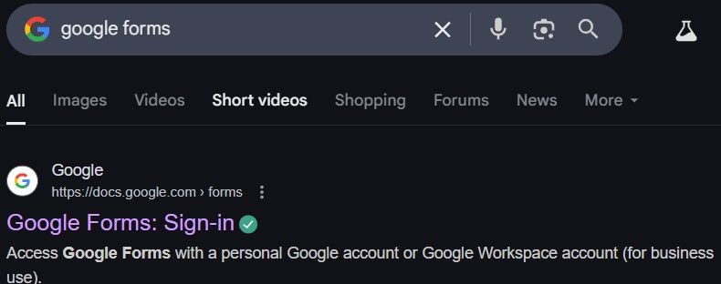

Select the Blank Template to create a new form or you can select any of them which are in ready made already

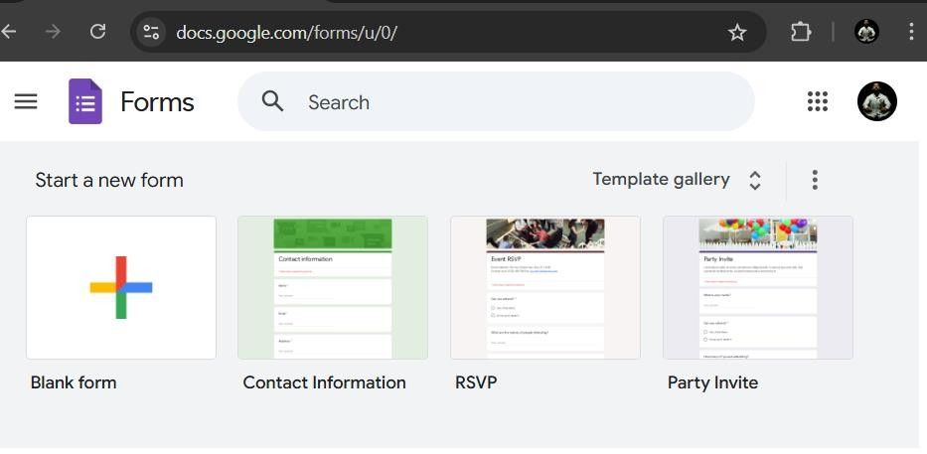

I have choosen the Blank form to create a new exam portal form !

* After choosing Blank form it show’s like

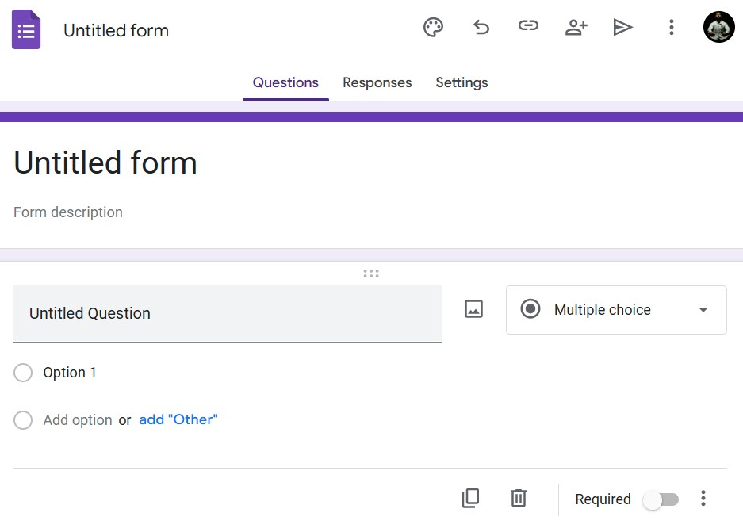

* Create the form as per your prerequisites like I have created it

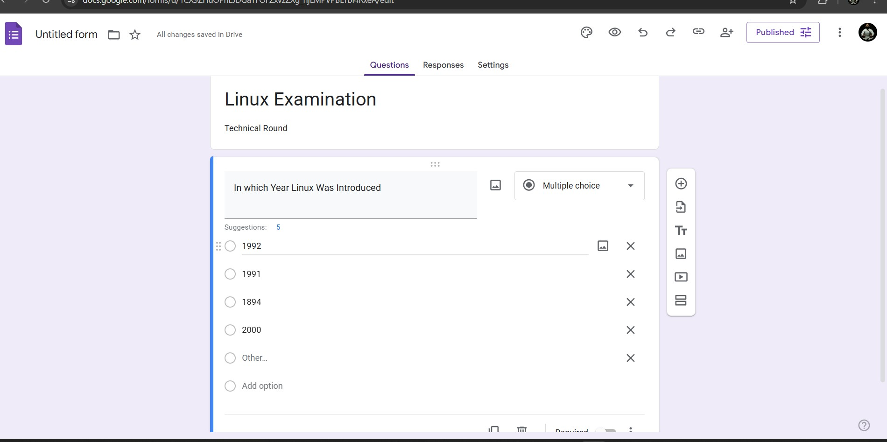

* And then copy the link of that form using link option at top of the form



* Then paste it in the bottom of the HTML code using VI EDITOR – This is one method and another method was using NANO
* Using NANO – Open your PuTTy and type command like



* And then enter into it paste the form link
* Then Save it using – [ :wq! ] as I said before
* After Creating a website
* Whoever open and answer that questions those persons count will be

display on the screen like

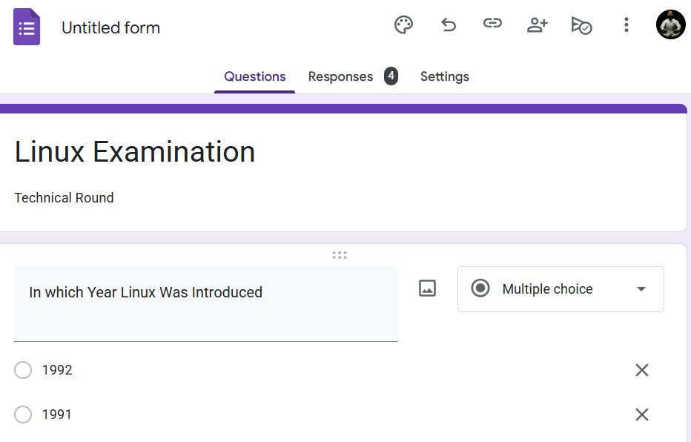

* If you open that “RESPONSES” section you can see the result in the form pie diagram like

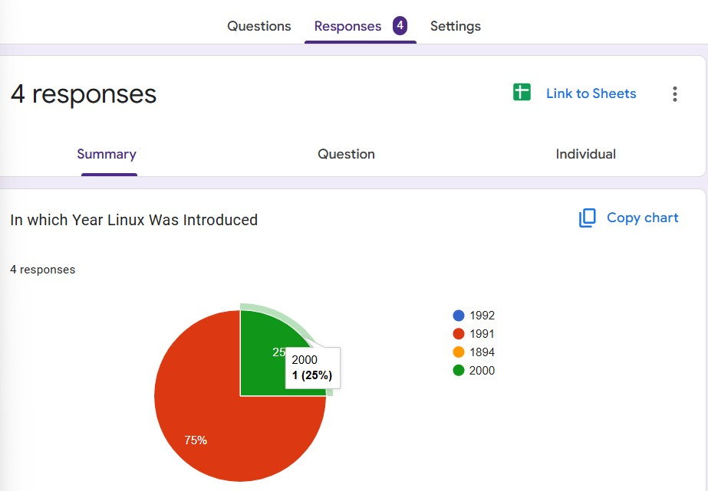

# FINAL CHECKS

* We can access our website using our website link to see the exam portal
* My website link was <https://forms.gle/8tUCPHzJXm1vZSL46>
* **Verify Apache is running** :



* **Ensure firewall settings are correct** :



# SUMMARY

* **CentOS 9 Installation**
* **Apache Server Configuration**
* **HTML Code Building**

* **Firewall Configuration**
* **Website Created**